MATH E-3 Assignment 6

Please show your work.

The Normal Distribution Curve

You can draw your distribution curves by hand or draw using a program like Microsoft Word or Paint. Please be neat whatever method you decide to employ. You will need to show the mean and the values for plus or minus 1 standard deviation and 2 standard deviations along with the rough and ready percentages that apply. There is no need to show 3 standard deviations.

Problems 1 through 8

A quality control engineer for a major toy company recently performed some statistical analysis on the length of plastic screws produced by its ‘Plastics Division.’ These particular screws are used in the construction of certain children’s toys, so their length is important in the structural integrity of the toys. Thus, a check is periodically performed. He found that the mean length of the screws is 4.5 centimeters and the standard deviation is 0.2 cm.

Answer the following. Make sure you draw the appropriate diagram for the normal distribution of these screws.

- Draw Diagram here:

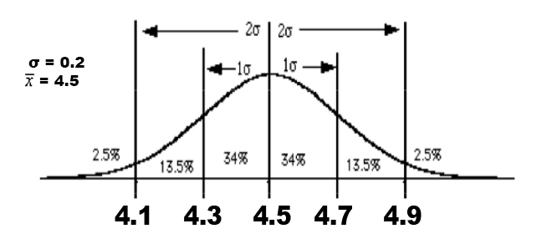

Assume the quality control engineer chooses one screw at random. What percentage of the time will the length of the screw be:

2) More than 4.7 cm?

16%

3) Less than 4.1 cm?

2.5%

4) More than 4.3 cm?

84%

5) Less than 4.9 cm?
97.5%

6) Less than 4.5 cm?

50%

7) Between 4.1 and 4.9 cm?
95%

8) Between 4.7 and 4.9 cm?
13.5%

The Normal Distribution Curve

You can draw your distribution curves by hand or draw using a program like Microsoft Word or Paint. Please be neat whatever method you decide to employ. You will need to show the mean and the values for plus or minus 1 standard deviation and 2 standard deviations along with the rough and ready percentages that apply. There is no need to show 3 standard deviations.

Problems 9 through 13

The 911 emergency center in a certain city receives various numbers of calls on different days. A record of the center shows that the number of daily calls is normally distributed with mean of 200 and standard deviation of 30. Remember to sketch a diagram.

9) Draw diagram here:

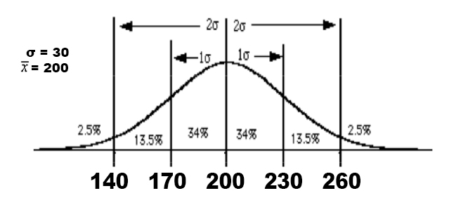

10) What percent of the days in this record have fewer than 140 calls?

2.5%

11) What percent of the days in this record have more than 230 calls?

16%

12) What percent of the days in this record have between 170 and 260 calls?

84%

13) What percent of the days in this record have more than 260 calls?

2.5%
The new formula for standard deviation, and 95% Confidence Intervals. Please give standard deviations as a percent, rounded to one decimal point. Round after turning into a percent.

Problems 14-16

For the following problems, calculate the standard deviation using our new formula. Show all your work as done in class. No diagram necessary for these questions.

14) Assume p = 67% and our sample size, n = 450.

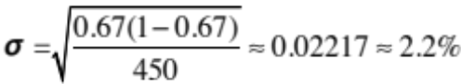

15) Assume p = 55% and our sample size, n = 1000.

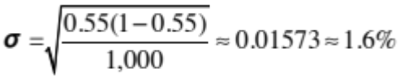

16) Assume p = 14% and our sample size, n = 250

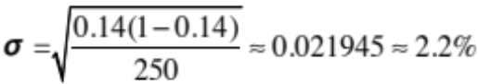

The new formula for standard deviation, and 95% Confidence Intervals. Please give standard deviations as a percent, rounded to one decimal point. Round after turning into a percent.

Problems 17-23

17) The University of Michigan Survey Research Center conducted a survey of 3000 people in 2013. 25% of those surveyed said they felt unhappy about their jobs. Find a 95% Confidence Interval for the true proportion of people who felt unhappy about their jobs.

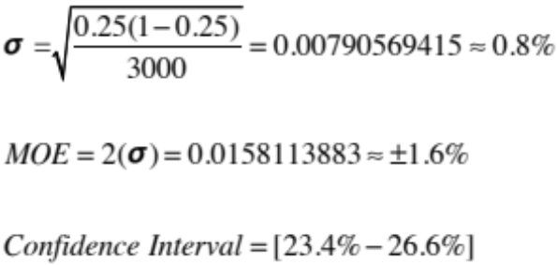

18) In July, 1998, the National Science Foundation commissioned a survey which revealed that vast numbers of American adults are scientifically illiterate. A Boston Globe article describing the results of this study reported that of 2000 adults questioned, only 52% knew the earth revolved around the sun and not the other way around!!! Assuming this was a random sample of all American adults, find a 95% confidence interval for the true proportion of scientifically knowledgeable American adults.

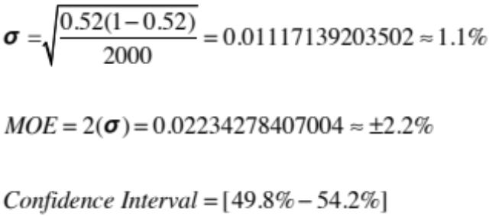

19) For the above problem 18, how would the size of the Confidence Interval change if four times as many American adults were surveyed? Explain why your answer is different (if it is) and show your calculations to prove your answer.

Claim:

If you increase the sample size by a factor of 4, the confidence interval will not decrease by one half.

Proof:
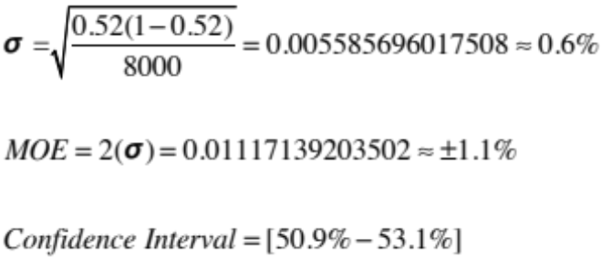
Conclusion:

Multiplying the result presented above by a factor of 2 will result in our original confidence interval mentioned in question 18. Thus we cannot accept the presented claim above and conclude our proof by induction.

20) What if the size of the survey in problem 18 was one-fourth as large? i.e. 1/4 of 2000? Again, explain and show your calculations.

Claim:

If the size of the survey in problem 18 was one-fourth as large, the confidence interval will not increase by a factor of 2.

Proof:
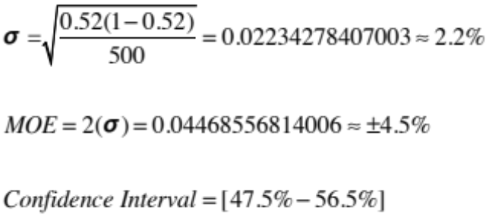
Conclusion:

Dividing the result presented above by 2 will result in our original confidence interval mentioned in question number 18. Thus we cannot accept the presented claim above and conclude our proof by induction.

21) The Encyclopedia Britannica reports that 6% (use this value for your mean=p) of all North American males have some form of red-green color blindness. Imagine that you take a random sample of 141 North American males. What is the probability that in this sample over 8% of these people will be colorblind? Hint: You may need to draw a normal distribution curve to answer this question.

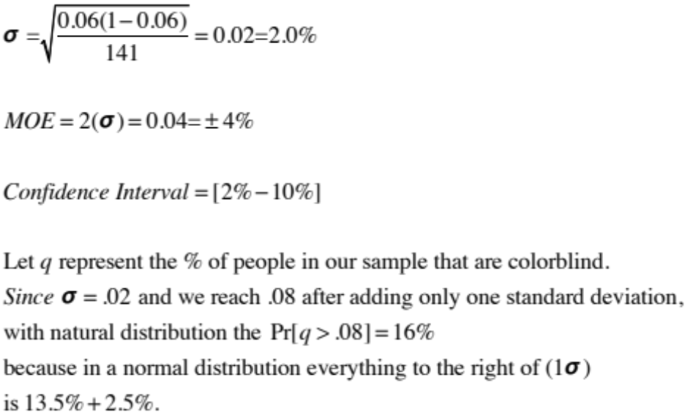

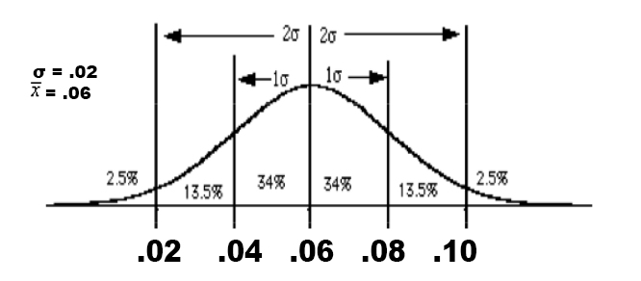

22) In yet another article in the Boston Globe (back in May of 1989) it was reported that in a study of 854 young women (ages 12-23) about 71% of them were dissatisfied with their weight. Assuming once again that this was a random sample, find a 95% Confidence Interval for the true proportion of young women (ages 12-23) who were dissatisfied with their weight.

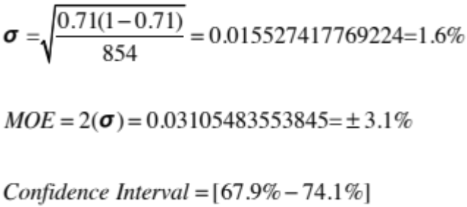

Optional extra credit problem

23) How much smaller a group could you have surveyed in problem 22 if you were willing to accept a 95% Confidence Interval of
71% ± 5%

You can use trial and error or algebra. There is nothing wrong with trial and error. No extra credit if you do it algebraically. In either case, we will give you 1 point extra credit if you get within 5 of the true answer. Round your answer to a whole number since we can’t survey parts of people! To solve the problem algebraically, you will have to use the new formula “in reverse.” I.e. instead of knowing p and n and solving for the standard deviation, you will start by knowing the standard deviation and p and solving for n. That’s one of the great things about formulas – you can generally use them in more than one way.

310.0
Because 1-0.71 = .31
31 * 10 = 310.

Also to double check Sqrt((1-0.71)*(0.71) / 310) * 2 = 5%

